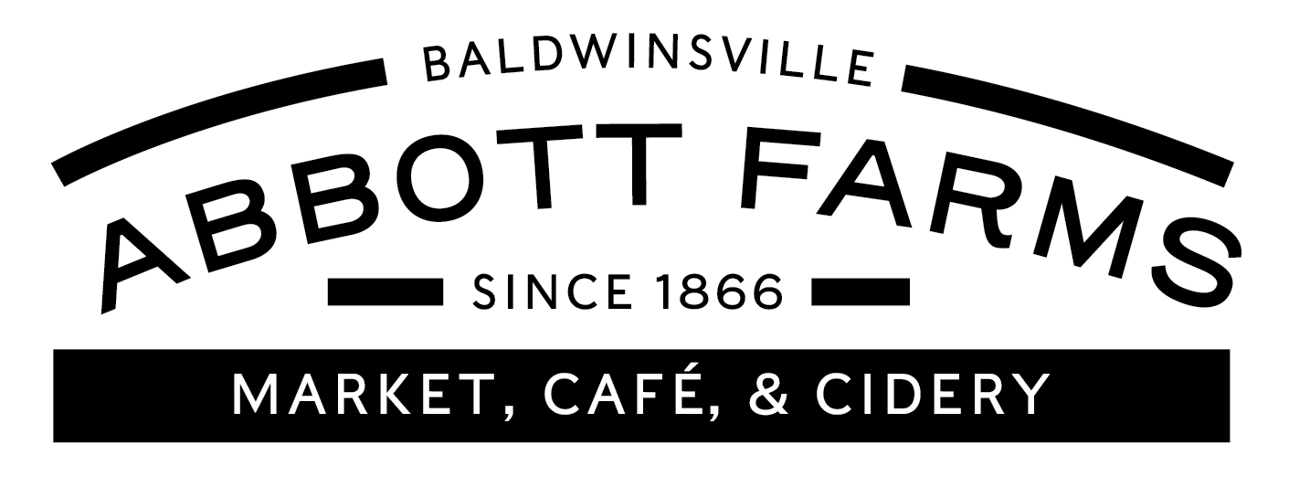

Abbott Farms 2024 CSA- Guidelines & Contract
Please be sure to read through our guidelines very carefully before submitting your application.
The Abbott Family Farm has been producing quality produce for 5 generations. What started as a dairy farm back in the 1800’s is now a full service U-pick farm offering families a fresh, nutritional variety of fruits and vegetables harvested weekly at their peak. We pack the produce into boxes for every member and have them ready for pick up on appointed days and times. Our harvest season runs 12 weeks from June through October.
CSA is a partnership between the members and the farmers. At the core of CSA is the idea that members support their farmer by sharing in the inherent risks of agriculture (poor weather, drought, disease, early frost, crop failure, and so on) and rewards (the bounty from a good season!). Therefore while Abbott Farms will act in good faith to provide fresh produce for the 16 weeks, there is a no guarantee of quantities or contents of weekly shares.

Members Responsibilities
Stay Informed! The single most important responsibility of all members is to educate themselves about the working of the CSA program by thoroughly reading through the website and reading the weekly Abbott Farms newsletter sent by email and posted on our Facebook page. You will find a harvest schedule, tips on storage and care of produce, and much more information about how to get the best use of your share.

Pick Up Your Share
As a CSA member you must pick up your share on your chosen pick up day and time. To ensure the freshest produce we will only harvest prior to your designated pick up day. Please choose from one of our two available pick up days and locations. If you are unable to pick up that day you may designate an alternate to pick up your share that week. Please just email or call us with their name. Our goal is to have you enjoy your share each week; we will work with you if you give us enough advance notice. If you do not pick up your share and do not designate an alternate to do so for you, you then forfeit your share that week and it will be donated to the local food bank. There is no refund for unclaimed shares.

Pick up days are: Wednesday 3-7pm at The Market
Be An Active Participant In The Program
We encourage all our members to become active participants in the CSA Program. You can do this by staying up to date with news from the farm (by checking our website or facebook page) and keeping in touch with the farm. Communication is critical! Please email us often with your suggestions, comments, or concerns. This is one of the greatest perks of CSA you can actually talk to the farmer who is growing your food! We also invite you to visit the farm and see what is new and exciting in the farm market.

Our Shares
Abbott Farms CSA Program is an 12 week membership share. Our season begins the mid June and goes through the end of October, weather permitting.
Full Share: The largest share offers on average 12-15lbs. of produce each week. Ideal for families of 4 or more. Includes Eggs
Half Share: On average 6-10lbs of produce ideal for families of up to 4.
Individual Share: On average 5lbs of produce. The perfect size for a single person or couple.
You will also receive a membership card which entitles you to 10% off anything in the Market and any events held here at the farm.

Complete The Application Form
Thank you! Please complete the contract and membership form and return it with your payment (cash, check, or credit card) to Abbott Farms 3275 Cold Springs Rd. Baldwinsville, NY 13027. After we receive your application we will process it, and then send you an email to verify our receipt of your signed contract. Once we are ready to harvest we will email you or call to remind you that pick up begins that week. THANKS!!!

If you have any questions, please do not hesitate to call us at 315-638-7783 or email us at aabbott@abbottfarms.com Either Warren or Alice will be able to answer any question you may have.

Abbott Farms 2024 CSA Membership Form
Member Name__________________________________________________________________
Email Address___________________________________Phone___________________________
Mailing Address_________________________________________________________________
City__________________________________State__________Zipcode_____________________

CSA Share
___ Full Share - $795 Family of 4 or more Eggs included ____½ gal of whole or 2% milk $60(please circle)
____Half Share $650 Family of up to 4 ____1 dozen brown eggs $58
___Individual Share $325 single person or couple

Pick Up Day
Pick up days are very important. To ensure the freshest produce we will only harvest prior to your designated pick up day. If you do not pick up your share or make no arrangements to have someone else pick it up for you, you then forfeit your share for that week and it will be donated to local charities. There is no refund for unclaimed shares.
We will not hand out shares on Saturday or Sunday during apple season (Aug.25th-Oct.31st)
___________Wednesday 3-7pm in the Market
CSA Contract
By signing this contract you are agreeing to participate in the Abbott Farms CSA. You understand the guidelines explained above and are willing to accept the risks. You will pick up or arrange for pick-up of your share each week. You understand there are no refunds. I appreciate locally grown produce and want to ensure that it remains available in my area by becoming a shareholder in Abbott Farms Community Supported Agriculture Program. I understand that Abbott Farms will do their best to provide sustainably produce fruit and vegetable varieties at the times they estimate. However, as a shareholder in both the bounty and the risk, I understand that nature ultimately decides what I will receive and when I receive it.

Signed_______________________________________________Date_____________________

